DO NOT GRANT PERMISSION
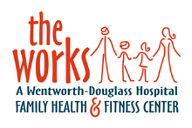
Clubhouse Kids Photo Release Form

I, __________________________________ hereby grant / do not grant the Works Family Health & Fitness Center permission to publish my child’s photograph(s):

______________________________________
(Child’s Name)

in agency publications and/or on the agency website located at www.theworkshealthclub.com.

I understand that I have the right to request, in writing, removal of the photo from the website within 30 working days of receipt of the request by The Works Family Health & Fitness Center.

I understand that this photo may be used in agency publications or on a website designed to promote the agency’s services as well as offer information and resources.

By signing below, I acknowledge my understanding of the above and grant my permission for use of the photograph(s).

(Please Print Name) (Date)

__________________________________________________________________
(Signature) (Date)

(If you do not wish that your child’s photo be used, please fill in their name, sign and date at the bottom of the form and check the box at the top of the form. Thank you!)

